
Common Security Module
Common Logging Module
CSM CLM Use Case Document

Version No: 1.0

Author : Kunal Modi
Team : Common Security Module (CSM)
Purchase Order# 34552
Client : Nation Cancer Institute - Center for Bioinformatics,
National Institutes of Health,
US Department of Health and Human Services

Document History
Document Location
The most current version of this document is located in CVS under security/docs.

Revision History
Version Number | Revision Date | Author | Summary of Changes
1.0 |  | Kunal Modi | Auto Generated from EA

Review
Name | Team/Role | Version | Date Reviewed | Reviewer Comments

Related Documents
More information can be found in the following related CSM documents:

Document Name

Table of Contents

1. Use Case Details 4
1.1 Use Case Model 4
1.1.1.1 13.1 Log events 6
1.1.1.2 13.10 Log object state before update 6
1.1.1.3 13.11 Log object state after update 7
1.1.1.4 13.12 Log object state before deletion 8
1.1.1.5 13.13 Log confirmation of object deletion 9
1.1.1.6 13.14 Log "user account is locked" 10
1.1.1.7 13.15 Create log entry in configurable source 10
1.1.1.8 13.2 Log object states 11
1.1.1.9 13.3 Log "user logs in" event 11
1.1.1.10 13.4 Log "user logs out" event 12
1.1.1.11 13.5 Log "login attempt failed" with user credential event 13
1.1.1.12 13.6 Log the Event in Audit Trail Message 13
1.1.1.13 13.7 Configurable destination for Audit Messages 14
1.1.1.14 13.8 Log object state on insertion 15
1.1.1.15 13.9 Log object state after insertion 16

Model Documentation

CSM / CLM Use Case Details

Use Case Model
Type: Package
Status: Proposed. Version . Phase 1.0.
Package: Use Case View
Detail: Created on 1/18/2005 1:38:43 PM. Last modified on 1/18/2005 1:38:46 PM
GUID: {B2633AC9-3C17-410c-B878-3F1BC5C29ECB}

Logging_Auditing_3.1 - (Use Case diagram)
Created By: Eric Copen on 9/21/2005
Last Modified: 4/5/2006
Version: 1.0.
GUID: {8BC5FC18-6F70-4616-844C-E6BDD0C3B85B}

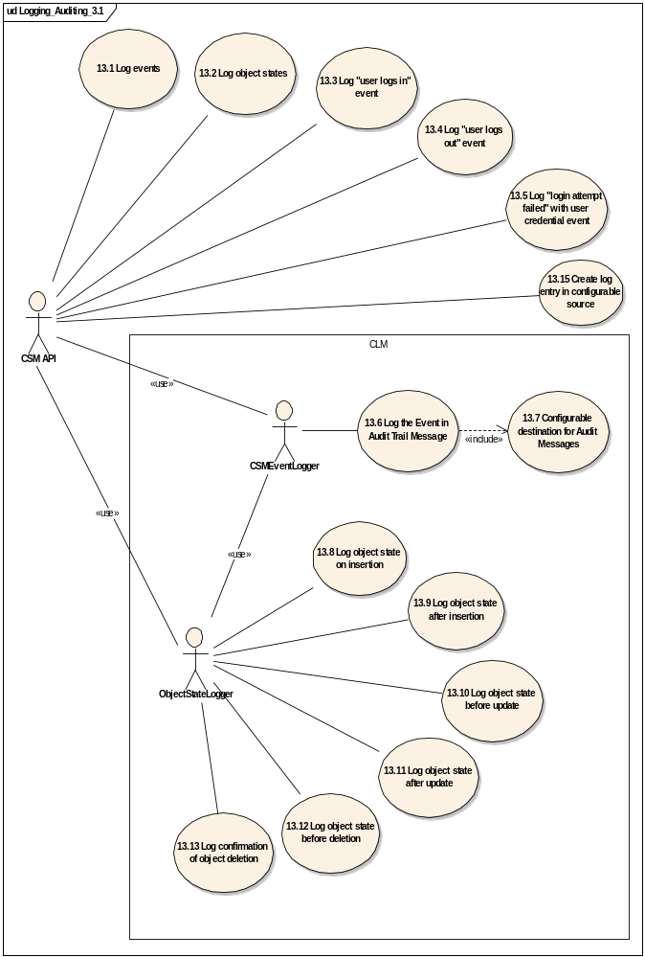

Type: Object
Status: Proposed. Version 1.0. Phase 1.0.
Package: Use Case Model Keywords:
Detail: Created on 10/7/2005. Last modified on.10/7/2005.
GUID: {25AC752E-2F59-4a45-838B-20BCF0829D5B}

13.1 Log events
Type: UseCase
Status: Proposed. Version 1.0. Phase 3.1.
Package: Use Case Model Keywords:
Detail: Created on 10/4/2005. Last modified on.10/14/2005.
GUID: {7C6A6CA4-1427-4a33-BA31-E4C77BF4999E}

The CSM API uses the CSMEventLogger to log event occurrences into the configurable destination for audit messages. Event messages should include user information, time-stamp, type, and description.

Constraints
• | Audit flag turned on : (Pre-condition.Status is Approved )  CSM should be enhanced to have a configurable flag to start and stop logging. This flag must be turned on for this use case to function.

Scenarios
• | Basic Flow Basic Path  1. Event takes place2. CSM API uses CSMEventLogger to log event information in persistent media.

Connections
Connector | Source | Target | Notes
Association  Unspecified | Public  CSM API | Public  13.1 Log events

13.10 Log object state before update
Type: UseCase
Status: Proposed. Version 1.0. Phase 3.1.
Package: Use Case Model Keywords:
Detail: Created on 9/21/2005. Last modified on.10/18/2005.
GUID: {9C2B3C98-9F76-4e9b-AF46-82EAD413D7EE}

CSM CSM ObjectStateLogger should log the state of the object just before an update.

Constraints
• | Audit flag turned on : (Pre-condition.Status is Approved )  CSM should be enhanced to have a configurable flag to start and stop logging. This flag must be turned on for this use case to function.
• | User Logged In : (Pre-condition.Status is Approved )  The user must have previously logged in and be in session.
• | Permission to update object : (Pre-condition.Status is Approved )  The user must have permission to update the object.

Scenarios
• | Basic Flow Basic Path  1. User enters information and selects a button to update an object.2. System logs the state of the object just before an update. 3. System logs record of update event (CSMEventLogger).
• | Update fails Exceptional  1. This scenario begins after step 1 of the basic flow.2. The update fails for any reason3. The ObjectStateLogger logs the state of the object before and after the exception.4. The CSMEventLogger logs the exception and the occurrence itself, and passes on the state before and after the failure to the persisted audit trail.5. System returns user to prior page and displays exception.
• | Update would cause a duplicate entry Alternate  1. Begins after basic flow step 1.2. Actor attempts to update an object and doing so would cause an unallowed duplicate entry.3. Update would not occur.4. System logs attempt to update object (CSMEventLogger).5. System displays exception indicating updating the object would create a duplicate entry.

Connections
Connector | Source | Target | Notes
Association  Unspecified | Public  ObjectStateLogger | Public  13.10 Log object state before update

13.11 Log object state after update
Type: UseCase
Status: Proposed. Version 1.0. Phase 3.1.
Package: Use Case Model Keywords:
Detail: Created on 9/21/2005. Last modified on.10/18/2005.
GUID: {1BE09577-2C6D-4824-944E-1598C3A883FE}

CSM ObjectStateLogger should log the state of an object after an update has taken place.

Constraints
• | Audit flag turned on : (Pre-condition.Status is Approved )  CSM should be enhanced to have a configurable flag to start and stop logging. This flag must be turned on for this use case to function.
• | User Logged In : (Pre-condition.Status is Approved )  The user must have previously logged in and be in session.
• | Object updated : (Pre-condition.Status is Approved )  Actor has successfully updated an object.
• | Permission to update object : (Pre-condition.Status is Approved )  The user must have permission to update the object.

Scenarios
• | Basic Flow Basic Path  1. System logs the state of the object after the update has taken place.

Connections
Connector | Source | Target | Notes
Association  Unspecified | Public  ObjectStateLogger | Public  13.11 Log object state after update

13.12 Log object state before deletion
Type: UseCase
Status: Proposed. Version 1.0. Phase 3.1.
Package: Use Case Model Keywords:
Detail: Created on 9/21/2005. Last modified on.10/18/2005.
GUID: {E0AE715B-BA90-4cf2-9D87-F32626942EA2}

When deleting an object the state of the object before deletion should be logged.

Constraints
• | Audit flag turned on : (Pre-condition.Status is Approved )  CSM should be enhanced to have a configurable flag to start and stop logging. This flag must be turned on for this use case to function.
• | User Logged In : (Pre-condition.Status is Approved )  The user must have previously logged in and be in session.
• | Permission to delete object : (Pre-condition.Status is Approved )  The user must have permission to delete the object.

Scenarios
• | Basic Flow Basic Path  1. User selects a button to delete an object.2. System logs the state of the object just before it is deleted. 3. System logs record of deletion (CSMEventLogger).

Connections
Connector | Source | Target | Notes
Association  Unspecified | Public  ObjectStateLogger | Public  13.12 Log object state before deletion

13.13 Log confirmation of object deletion
Type: UseCase
Status: Proposed. Version 1.0. Phase 3.1.
Package: Use Case Model Keywords:
Detail: Created on 9/21/2005. Last modified on.10/18/2005.
GUID: {FF06199D-2036-410b-9E82-ACBCE8D5BC7D}

When deleting an object a confirmation of the delete should be logged.

Constraints
• | Audit flag turned on : (Pre-condition.Status is Approved )  CSM should be enhanced to have a configurable flag to start and stop logging. This flag must be turned on for this use case to function.
• | User Logged In : (Pre-condition.Status is Approved )  The user must have previously logged in and be in session.
• | Permission to delete object : (Pre-condition.Status is Approved )  The user must have permission to delete the object.
• | Deleted object : (Pre-condition.Status is Approved )  Object has been deleted.

Scenarios
• | Basic Flow Basic Path  1. System confirms object is deleted.2. System logs confirmation of object deletion

Connections
Connector | Source | Target | Notes
Association  Unspecified | Public  ObjectStateLogger | Public  13.13 Log confirmation of object deletion

13.14 Log "user account is locked"
Type: UseCase
Status: Proposed. Version 1.0. Phase 1.0.
Package: Use Case Model Keywords:
Detail: Created on 9/21/2005. Last modified on.4/5/2006.
GUID: {14E1FD40-CF95-419f-8794-24B2CD2E3177}

Incase of user lockout after the number of invalid attempts generate a log message depicting the same.

Connections
Connector | Source | Target | Notes
UseCase  Source -> Destination | Public  CSM API | Public  13.14 Log "user account is locked"
UseCase  Source -> Destination | Public  CSMEventLogger | Public  13.14 Log "user account is locked"

13.15 Create log entry in configurable source
Type: UseCase
Status: Proposed. Version 1.0. Phase 1.0.
Package: Use Case Model Keywords:
Detail: Created on 10/4/2005. Last modified on.4/5/2006.
GUID: {D4B360DE-53B6-4adb-B079-D3F331837A2E}

The client application should be able to configure where the logs would reside

Connections
Connector | Source | Target | Notes
Association  Unspecified | Public  CSM API | Public  13.15 Create log entry in configurable source

13.2 Log object states
Type: UseCase
Status: Proposed. Version 1.0. Phase 3.1.
Package: Use Case Model Keywords:
Detail: Created on 10/4/2005. Last modified on.10/18/2005.
GUID: {B253787A-E896-4603-9192-26091937FC3F}

The CSM API uses the ObjectStateLogger to log object states and then uses the CSMEventLogger to insert them into the configurable destination for audit messages.

Constraints
• | Audit flag turned on : (Pre-condition.Status is Approved )  CSM should be enhanced to have a configurable flag to start and stop logging. This flag must be turned on for this use case to function.

Scenarios
• | Basic Flow Basic Path  1. Event takes place that affects object state2. An object's state changes2. CSM API uses ObjectStateLogger and CSMEventLogger to log event information and object state information relevant to the event in persistent media.

Connections
Connector | Source | Target | Notes
Association  Unspecified | Public  CSM API | Public  13.2 Log object states

13.3 Log "user logs in" event
Type: UseCase
Status: Proposed. Version 1.0. Phase 3.1.
Package: Use Case Model Keywords:
Detail: Created on 9/21/2005. Last modified on.10/18/2005.
GUID: {6C70B5FA-CE51-4599-9D1D-C9A0ED4D9E6D}

CSM should log all "log in" events.

Constraints
• | Audit flag turned on : (Pre-condition.Status is Approved )  CSM should be enhanced to have a configurable flag to start and stop logging. This flag must be turned on for this use case to function.

Scenarios
• | Basic Flow Basic Path  1. The user enters username, password, and application name, and selects "Login"2. The system logs successful login and user ID only.
• | Invalid Credentials Exceptional  1. This scenario begins after step 1 in the basic flow if the user credentials are not valid.2. The system will log the login failures and log the credentials that the user provided during the failed logins.3. The system returns the user to the login page and step 1 of the basic flow.

Connections
Connector | Source | Target | Notes
Association  Unspecified | Public  CSM API | Public  13.3 Log "user logs in" event

13.4 Log "user logs out" event
Type: UseCase
Status: Proposed. Version 1.0. Phase 3.1.
Package: Use Case Model Keywords:
Detail: Created on 9/21/2005. Last modified on.10/18/2005.
GUID: {1363E872-E928-466b-A4CB-D11667037874}

CSM should be enhanced to log all log out events.

Constraints
• | Audit flag turned on : (Pre-condition.Status is Approved )  CSM should be enhanced to have a configurable flag to start and stop logging. This flag must be turned on for this use case to function.

Scenarios
• | Basic Flow Basic Path  1. The user selects "log out".2. The system logs log out event

Connections
Connector | Source | Target | Notes
Association  Unspecified | Public  CSM API | Public  13.4 Log "user logs out" event

13.5 Log "login attempt failed" with user credential event
Type: UseCase
Status: Proposed. Version 1.0. Phase 3.1.
Package: Use Case Model Keywords:
Detail: Created on 9/21/2005. Last modified on.10/18/2005.
GUID: {E095CD6B-5A4F-41df-8EDF-30DBADBB0F61}

CSM should log the login failures and log the credentials that the user provided during the failed logins.

Constraints
• | Audit flag turned on : (Pre-condition.Status is Approved )  CSM should be enhanced to have a configurable flag to start and stop logging. This flag must be turned on for this use case to function.

Scenarios
• | Basic Flow Basic Path  1. The user enters one or more incorrect credentials - username, password, or application name - when logging on. 2. The system logs the credentials that the user provided during the failed logins, along with the user information, time-stamp, type, and description.3. The system displays an error message and returns the user to the login page.

Connections
Connector | Source | Target | Notes
Association  Unspecified | Public  CSM API | Public  13.5 Log "login attempt failed" with user credential event

13.6 Log the Event in Audit Trail Message
Type: UseCase
Status: Proposed. Version 1.0. Phase 3.1.
Package: Use Case Model Keywords:
Detail: Created on 10/4/2005. Last modified on.10/18/2005.
GUID: {7349306D-2106-4e2f-8C12-FD456A9F0E5C}

CSMEventLogger will log the events in the way specified by CFR 21 / Part 11, and event messages should include user information, time-stamp, type, and description.

Constraints
• | CSM API provides event information : (Pre-condition.Status is Approved )  CSM API sends event message information to CSMEventLogger
• | ObjectStateLogger provides event information : (Pre-condition.Status is Approved )  ObjectStateLogger sends event message information (including object state) to CSMEventLogger

Scenarios
• | Basic Flow Basic Path  1. Receive message from CSMEventLogger or ObjectStateLogger2. Pass information in the form of an audit trail message into configurable persistent media so it can be retrieved in the future and analyzed.

Connections
Connector | Source | Target | Notes
UseCase  Source -> Destination | Public  13.6 Log the Event in Audit Trail Message | Public  13.7 Configurable destination for Audit Messages
Association  Unspecified | Public  CSMEventLogger | Public  13.6 Log the Event in Audit Trail Message

13.7 Configurable destination for Audit Messages
Type: UseCase
Status: Proposed. Version 1.0. Phase 3.1.
Package: Use Case Model Keywords:
Detail: Created on 10/4/2005. Last modified on.10/18/2005.
GUID: {C4AAC49A-0538-4a8b-8CEE-DA10473CB01E}

Audit trail records should be stored on a persistent media so that they can be retrieved in the future and analyzed. This media can be a file, database, etc.The retention period should be configurable for each application. There should be a backup strategy in place for all the records which are purged after the retention period.

Connections
Connector | Source | Target | Notes
UseCase  Source -> Destination | Public  13.6 Log the Event in Audit Trail Message | Public  13.7 Configurable destination for Audit Messages

13.8 Log object state on insertion
Type: UseCase
Status: Proposed. Version 1.0. Phase 3.1.
Package: Use Case Model Keywords:
Detail: Created on 9/21/2005. Last modified on.10/18/2005.
GUID: {1847278B-5E49-4327-AAA7-60DCDBD3977F}

When adding an object, the state provided by the user should be recorded.

Constraints
• | Audit flag turned on : (Pre-condition.Status is Approved )  CSM should be enhanced to have a configurable flag to start and stop logging. This flag must be turned on for this use case to function.
• | User Logged In : (Pre-condition.Status is Approved )  The user must have previously logged in and be in session.
• | Permission to create object : (Pre-condition.Status is Approved )  The user must have permission to create the object.

Scenarios
• | Basic Flow Basic Path  1. User enters object information and selects a button to create an object.2. System logs the state of the object just before insertion.
• | Insertion fails Exceptional  1. This scenario begins after step 1 of the basic flow.2. The insertion fails for any reason3. The ObjectStateLogger logs the state of the object before and after the exception.4. The CSMEventLogger logs the exception and the occurrence itself, and passes on the state before and after the failure to the persisted audit trail.5. System returns user to prior page and displays exception.

Connections
Connector | Source | Target | Notes
Association  Unspecified | Public  ObjectStateLogger | Public  13.8 Log object state on insertion

13.9 Log object state after insertion
Type: UseCase
Status: Proposed. Version 1.0. Phase 3.1.
Package: Use Case Model Keywords:
Detail: Created on 9/21/2005. Last modified on.10/18/2005.
GUID: {4C743522-7E43-429a-A988-D32CF1943DDD}

When adding an object, its initial state in the database should be logged.

Constraints
• | Audit flag turned on : (Pre-condition.Status is Approved )  CSM should be enhanced to have a configurable flag to start and stop logging. This flag must be turned on for this use case to function.
• | User Logged In : (Pre-condition.Status is Approved )  The user must have previously logged in and be in session.
• | Permission to create object : (Pre-condition.Status is Approved )  The user must have permission to create the object.
• | User enters object data to insert : (Pre-condition.Status is Approved )  User enters object information and selects a button to create an object.

Scenarios
• | Basic Flow Basic Path  1. System logs the state of the object after insertion. 2. System logs record of insertion (CSMEventLogger).

Connections
Connector | Source | Target | Notes
UseCase  Source -> Destination | Public  ObjectStateLogger | Public  13.9 Log object state after insertion

